Alternative/Similar Systems

This section will look at two systems that are similar to my project, namely ABNER and Citeology. It will provide a brief introduction to, and an evaluation of, each of these systems.

ABNER

ABNER, which stands for A Biomedical Named Entity Recogniser, is a Java based, open source NER tool designed to analyse molecular biology texts. Originally developed in 2004 by Burr Settles at the University of Wisconsin-Madison part of the NLPBA/BioNLP 2004 Shared Task challenge, its current version, 1.5, was released in 2005.

ABNER consists of a simple Java GUI and uses a statistical machine learning approach to identify and annotate named entities such as proteins, DNA, RNA and cell types. It is bundled as a Java archive (JAR) and includes a Java API to allow it be incorporated in to other applications.

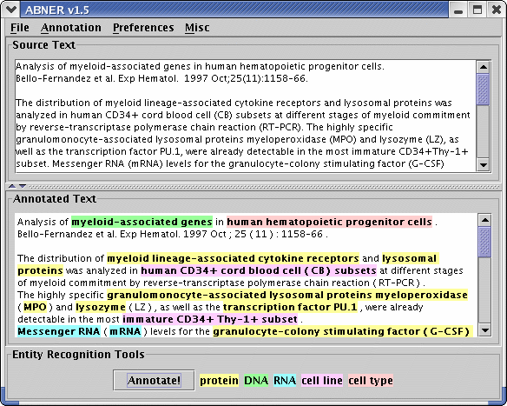

Figure 3: ABNER screenshot

Evaluation

Usability:

Clarity of Data:

Documentation:

F1 Measure:

Citeology

Citeology is an interactive visualisation tool to show the relationship between research papers based on their citations. Citeology was developed as a Java applet by Justin Matejka, George Fitzmaurice and Tovi Grossman at Autodesk Research, as part of Autodesk's Visualization Project.

Evaluation

Usability:

Clarity of Data:

Documentation:

